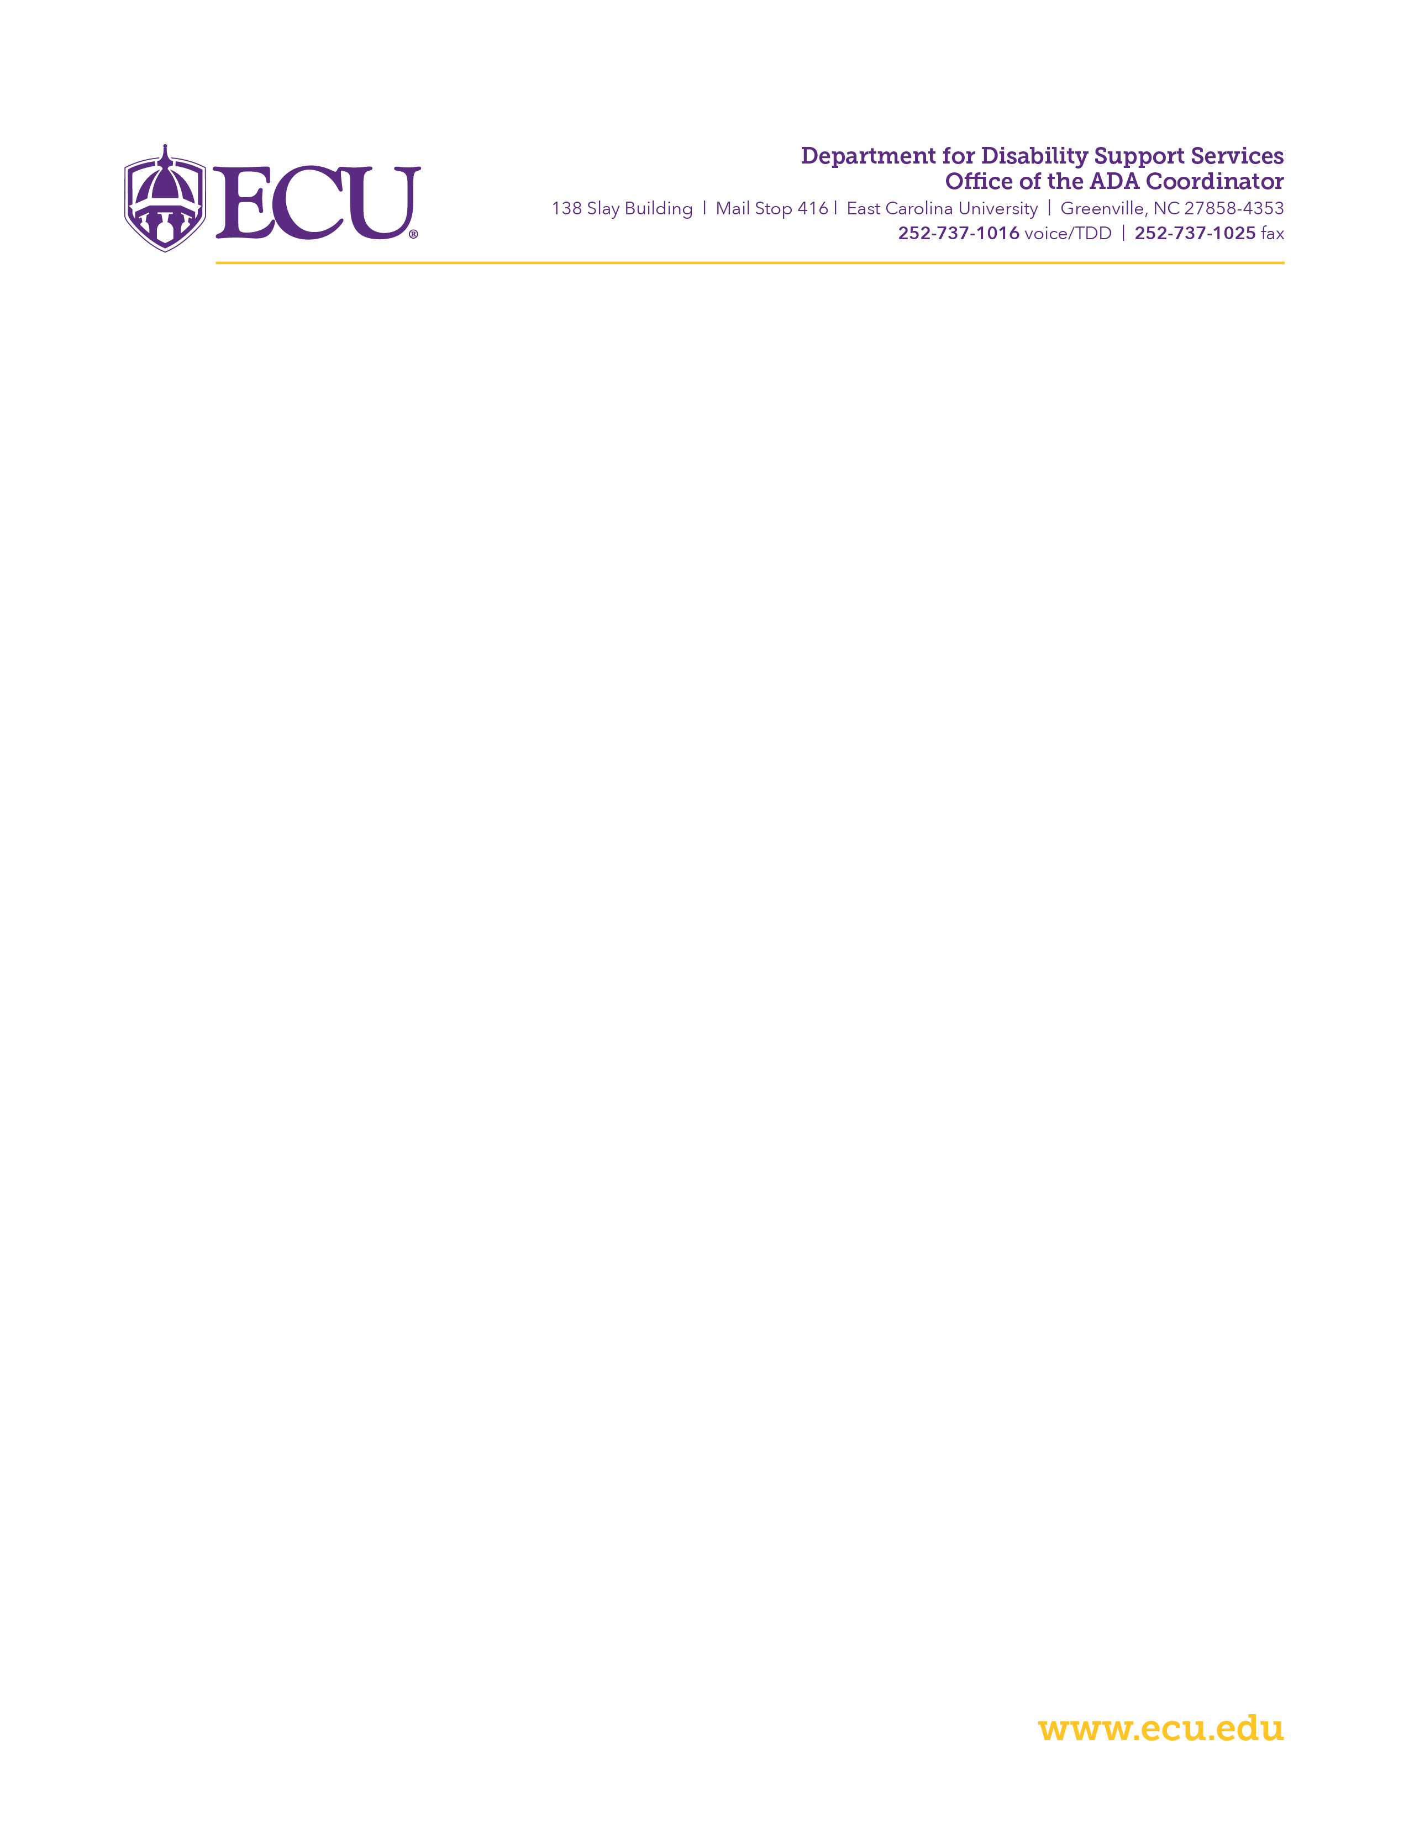

**Welcome, below are instructions for accessing electronic textbooks**.

**Requesting Electronic Textbooks:**

* Log on to [www.ecu.edu](http://www.ecu.edu), scroll to bottom right corner of homepage and click on Accessibility
* Click on Student Support Services (DSS)
* Under Student Services, click on Request Electronic Textbooks
* Read Instructions carefully
* Fill out form and submit

**(Note)**

Students must show proof of purchase in order to receive an electronic copy of textbook

Questions regarding Electronic Textbooks can be directed to Brian Stanford: [stanfordb17@ecu.edu](mailto:stanfordb17@ecu.edu)

All other questions can be addressed at [dssdept@ecu.edu](mailto:dssdept@ecu.edu) or calling the office at (252) 737-1016